

# CS 305 Project Two

**Practices for Secure Software Report**

**Table of Contents**

Document Revision History 3

Client 3

Instructions 3

Developer 4

1. Algorithm Cipher 4

2. Certificate Generation 4

3. Deploy Cipher 4

4. Secure Communications 4

5. Secondary Testing 4

6. Functional Testing 5

7. Summary 5

## Document Revision History

| **Version** | **Date** | **Author** | **Comments** |
| --- | --- | --- | --- |
| **1.0** | **April 17th** | **Alex Jarratt** |  |

## Client



## Instructions

Deliver this completed Practices for Secure Software Report documenting your process for writing secure communications and refactoring code that complies with software security testing protocols.

Respond to the steps outlined below and replace the bracketed text with your findings in your own words. If you choose to include images or supporting materials, be sure to insert them throughout.

## Developer

Alex Jarratt

## 1. Algorithm Cipher

Determine an appropriate encryption algorithm cipher to deploy given the security vulnerabilities, justifying your reasoning. Be sure to address the following:

* Provide a brief, high-level overview of the encryption algorithm cipher.
* Discuss the hash functions and bit levels of the cipher.
* Explain the use of random numbers, symmetric vs non-symmetric keys, and so on.
* Describe the history and current state of encryption algorithms.

The algorithm Cipher that will be used given the client’s security vulnerabilities and the expected attack types, SHA-256 seems to be the clear winner. SHA-256, or Secure Hash Algorithm, is the 2001 successor to the SHA-1 that the NSA created. The reasoning behind 256 is because SHA-256 will output a hash of 256 bits. The full details of SHA-256’s inner workings are unknown and are hidden behind government security measures making SHA-256 one of the most secure ciphers. Additionally, the usage of such long bit keys makes collisions, where two different inputs produce the same output, highly unlikely. This further enhances the security of SHA-256.

## 2. Certificate Generation

Generate appropriate self-signed certificates using the Java Keytool, which is used through the command line.

* To demonstrate that the keys were effectively generated, export your certificates (CER file) and submit a screenshot of the CER file below.

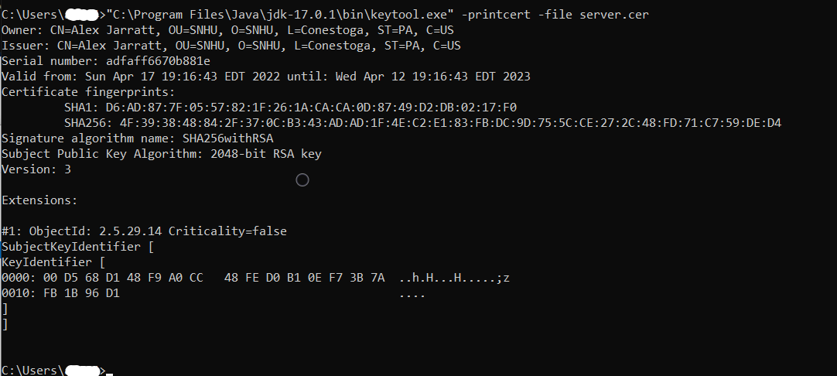

## 3. Deploy Cipher

Refactor the code and use security libraries to deploy and implement the encryption algorithm cipher to the software application. Verify this additional functionality with a checksum.

* Insert a screenshot below of the checksum verification. The screenshot must show your name and a unique data string that has been created.

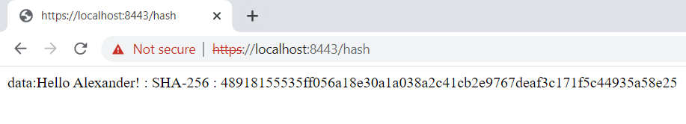

## 4. Secure Communications

Refactor the code to convert HTTP to the HTTPS protocol. Compile and run the refactored code to verify secure communication by typing **https://localhost:8443/hash** in a new browser window to demonstrate that the secure communication works successfully.

* Insert a screenshot below of the web browser that shows a secure webpage.

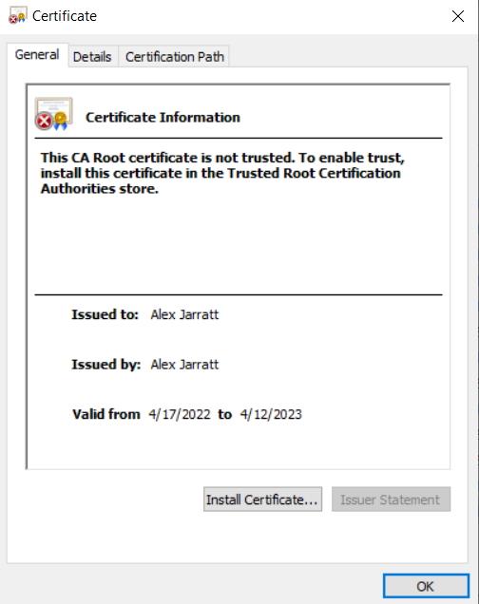

## 5. Secondary Testing

Complete a secondary static testing of the refactored code using the dependency check tool to ensure code complies with software security enhancements. You only need to focus on the code you have added as part of the refactoring. Complete the dependency check and review the output to ensure you did not introduce additional security vulnerabilities.

* Include the following below:
  + A screenshot of the refactored code executed without errors
  + A screenshot of the dependency check report

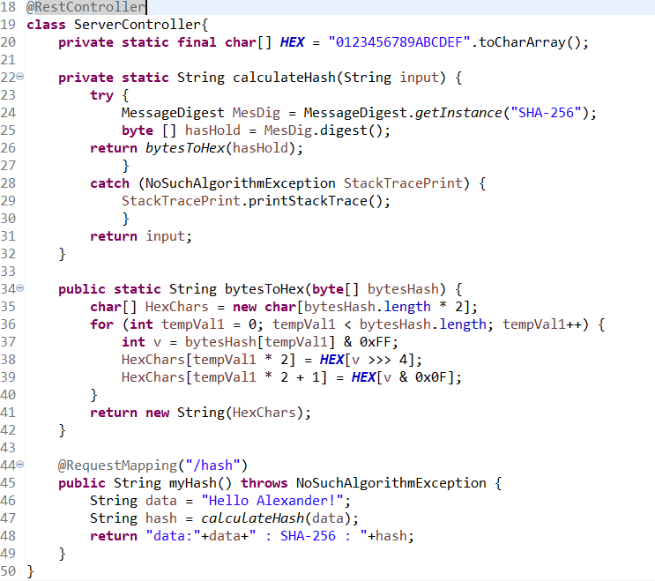

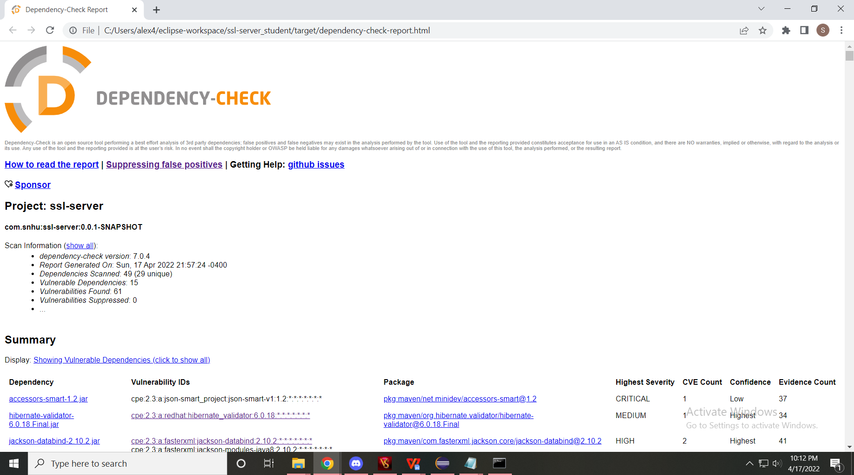

## 6. Functional Testing

Identify syntactical, logical, and security vulnerabilities for the software application by manually reviewing code.

* Complete this functional testing and include a screenshot below of the refactored code executed without errors.



## 7. Summary

Discuss how the code has been refactored and how it complies with security testing protocols. Be sure to address the following:

* Refer to the Vulnerability Assessment Process Flow Diagram and highlight the areas of security that you addressed by refactoring the code.
* Discuss your process for adding layers of security to the software application and the value that security adds to the company’s overall wellbeing.
* Point out best practices for maintaining the current security of the software application to your customer.

In refactoring the code the biggest areas of security affected was in web communication. In terms of the Vulnerability Assessment Process Flow Diagram, this means I factored in API, Client/Server, and Cryptography. API Interactions with HTTPS communication methods. This includes the algorithm cipher taking the output of the program and encrypting it before posting it to the localhost. Additionally, the inclusion of exception handling removes the majority of errors. Continuing on, secure coding practices were utilized through the usage of a keystore for important and delicate information. Finally, maintenance of the code should be done at least once a month for any updates to the various plugins. These updates usually prevent older exploits from occurring in newer systems.